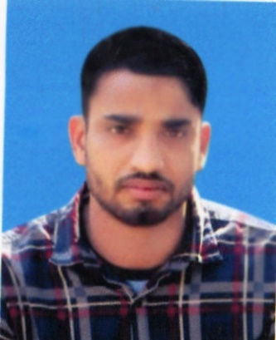

**CURRICULAM VITAE/CV**

**OF**

**MD.YOUSUF ALI**

Contact No: 0186-5618702

**Career Objective:**

To build up my career with honorable and challenging job in an organization where my conceptual and analytical skill can be utilized and further enhance my knowledge and experience.

**Personal Detalls:**

Name : Md Yousuf Ali

Father’s Name : Md Abdus Samad

Mother’s Name : Mst Resma Begum

Permanent Address : Vill:Gilabari, Post: Saptibari

Upazilla:,Aditmari Dist: Lalmonirhat.

Present Address : Vill: Gilabari, Post: Saptibari

Upazilla: Aditmari, Dist: Lalmonirhat.

Date of Birth : 18-April 2001

Nationallity : Bangladeshi (by birth)

Sex : Male

Religion : Islam

Marital Status : Unmarried

Mobile no : 0186-5618702

NID NO : 6010624291

Weight (kg) : 60

Height : 5.7

**Secondary School Certificate (s.S.C)**

Name of Board : Dinajpur

Name of the Institute : Saptibari High School.

Discipline : Science

Year of passing : 2016

GPA obtained : GPA-4.17

**Hiaher Secondary School Certificate (H.S.C)**

Name of Board : Dinajpur

Name of the Institute : Aditmari Govt. Collage

Discipline : Science

Year of passing : 2019 GPA obtained : GPA-3.33

**Computer Skilled**

**MS Word, MS Excel, Internet Browsing**

**I declared with confidence that all the information is true and other’s certificates & particulars are submitted to consider.**

**Signature**

(Md Yousuf Ali)

Date: